Tei Of Crete



Thesis Title: HeraklionGo

# ****Abstract****

This specific thesis concerns the creation of an augmented reality game on android phones that was made with the assist of Unity game engine and some programming languages such as C# and PHP.

The goal of this game is that the player has to search Heraklion city with his Gps open in order to find some shops so he can buy weapons to increase his stats and also find some coliseums where he can fight with other players and if he wins he will gain more health and money so he can buy more weapons and get stronger.

# Game Screenshots:

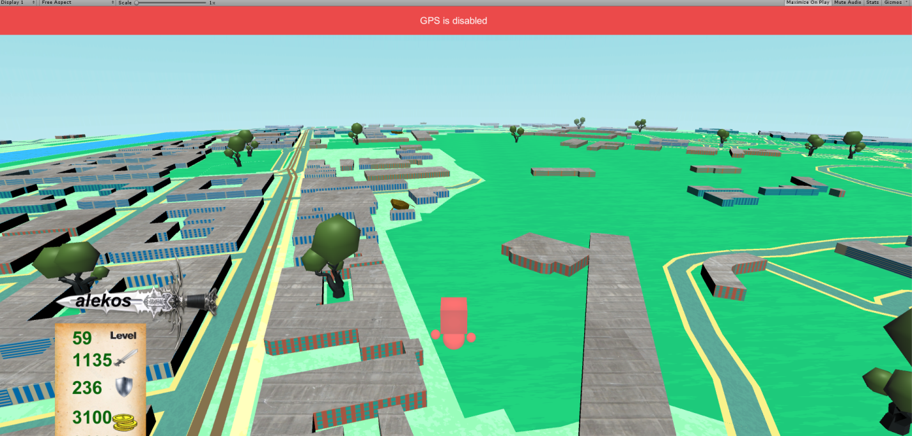

Figure :When Gps is disabled

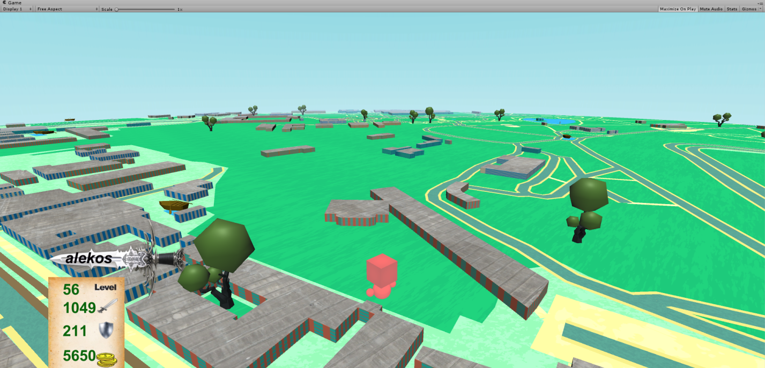

Figure :When Gps is enabled

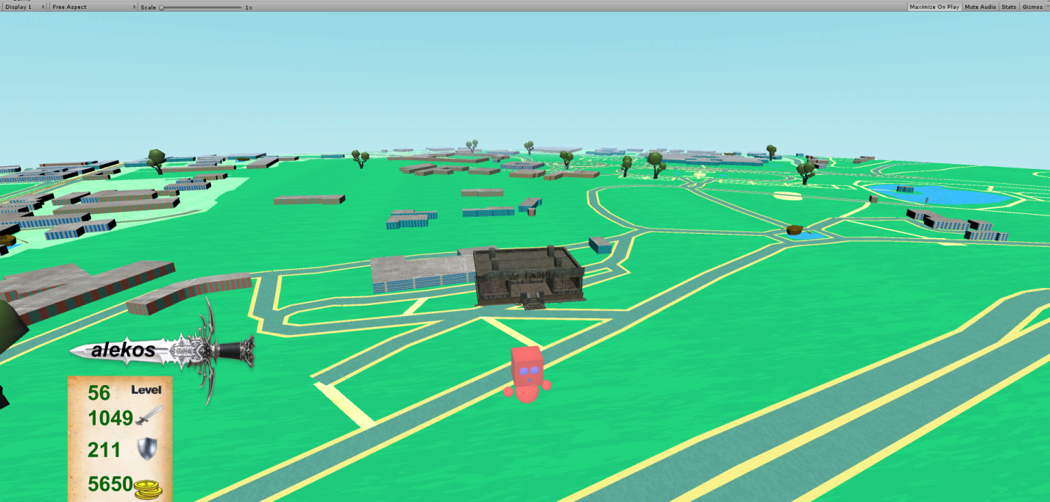

Figure :3D Object Of A Shop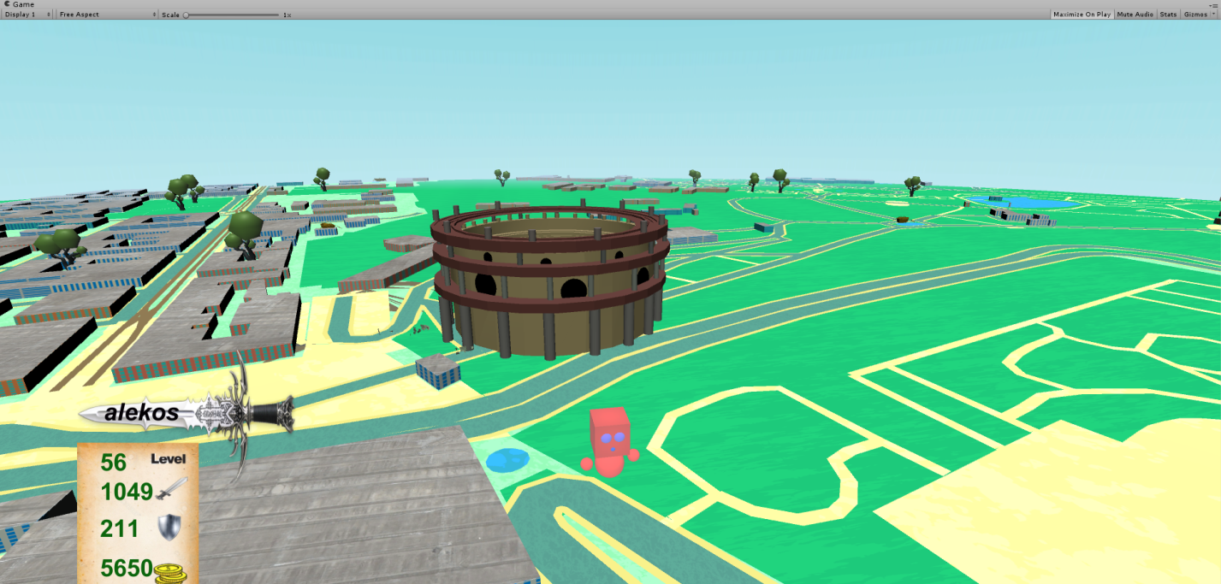

Figure :3D Object Of A Coliseum

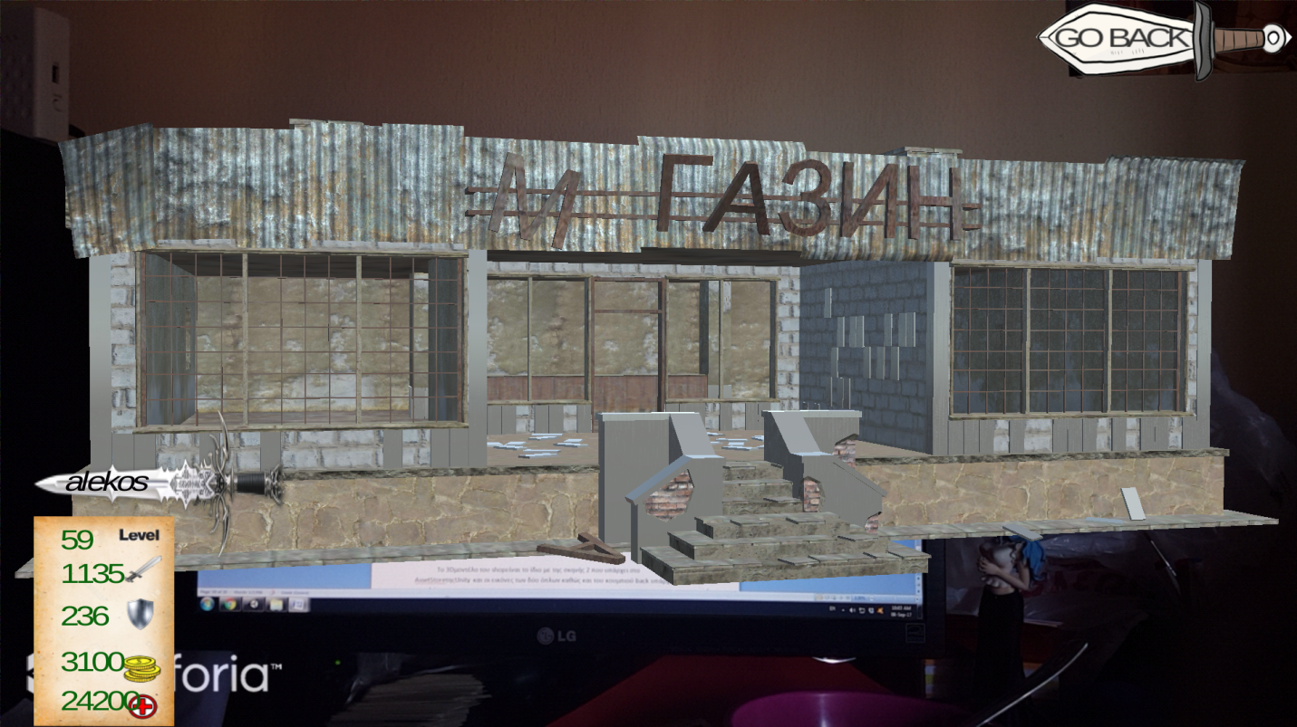

Figure :AR Looking Shop

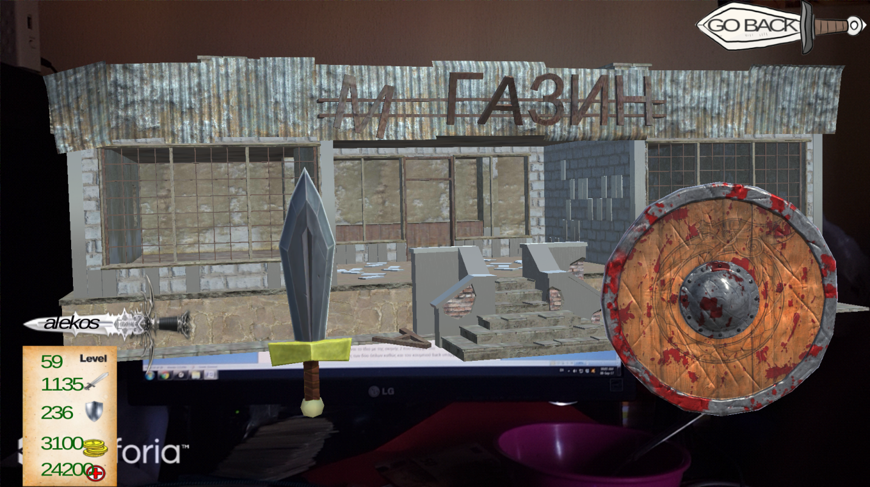

Figure :AR Looking Shop

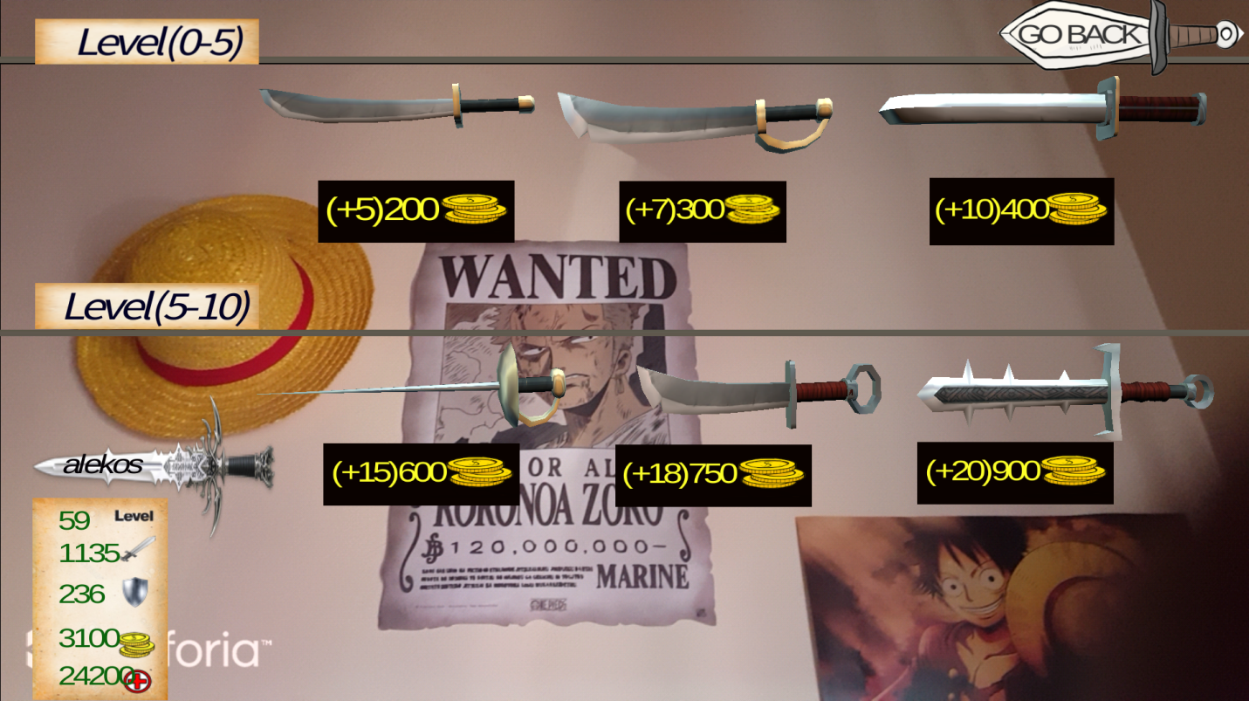

Figure :AR Buy Swords

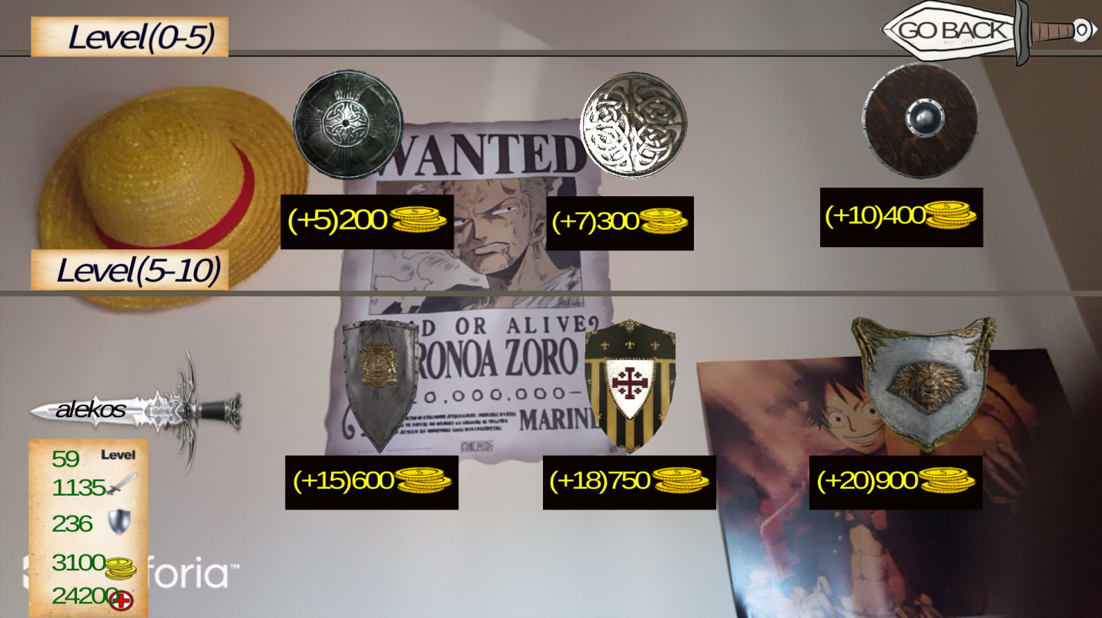

Figure :AR Buy Shields

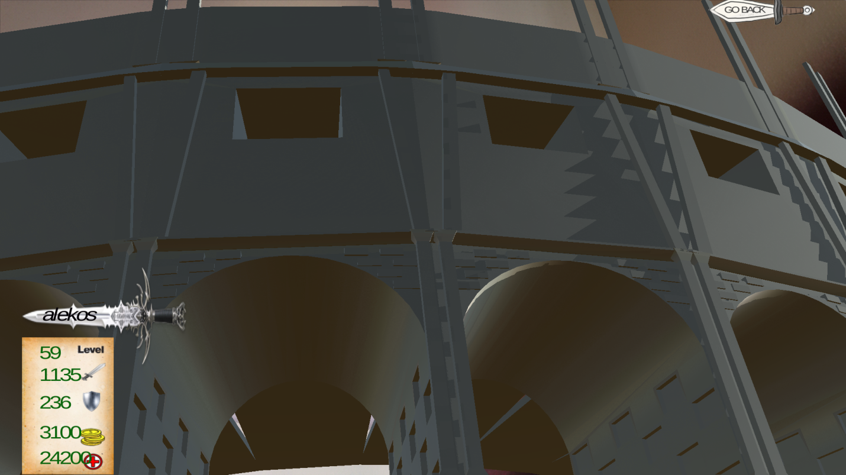

Figure :AR Looking Coliseum

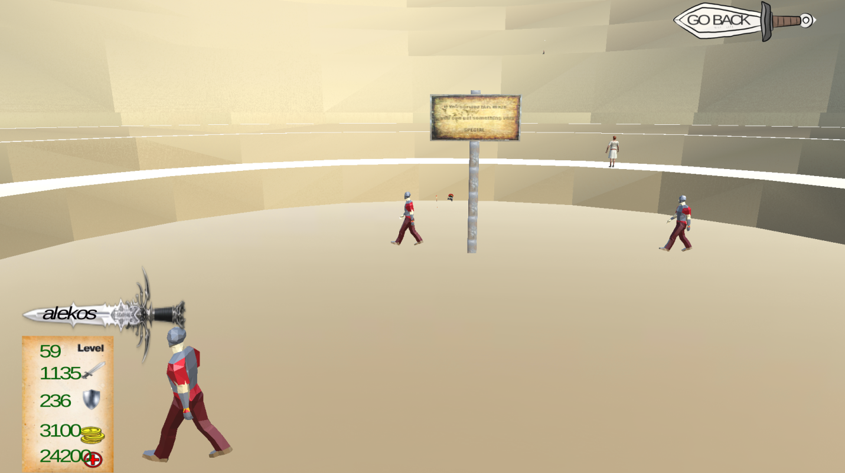

Figure :Inside Coliseum Scene

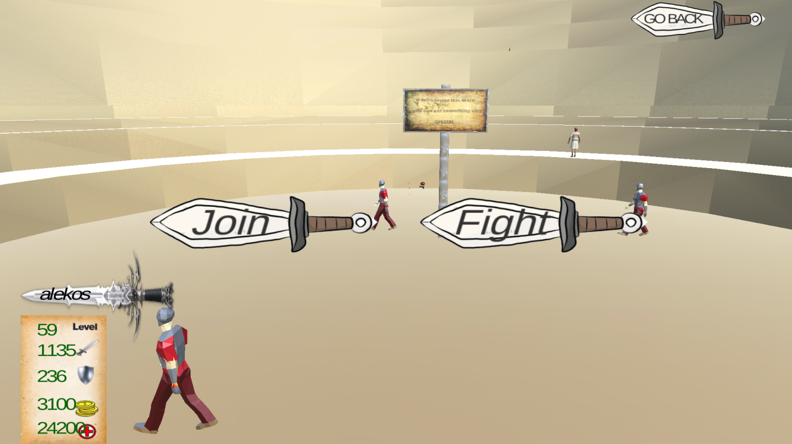

Figure :Choose To Fight Now Or Just Join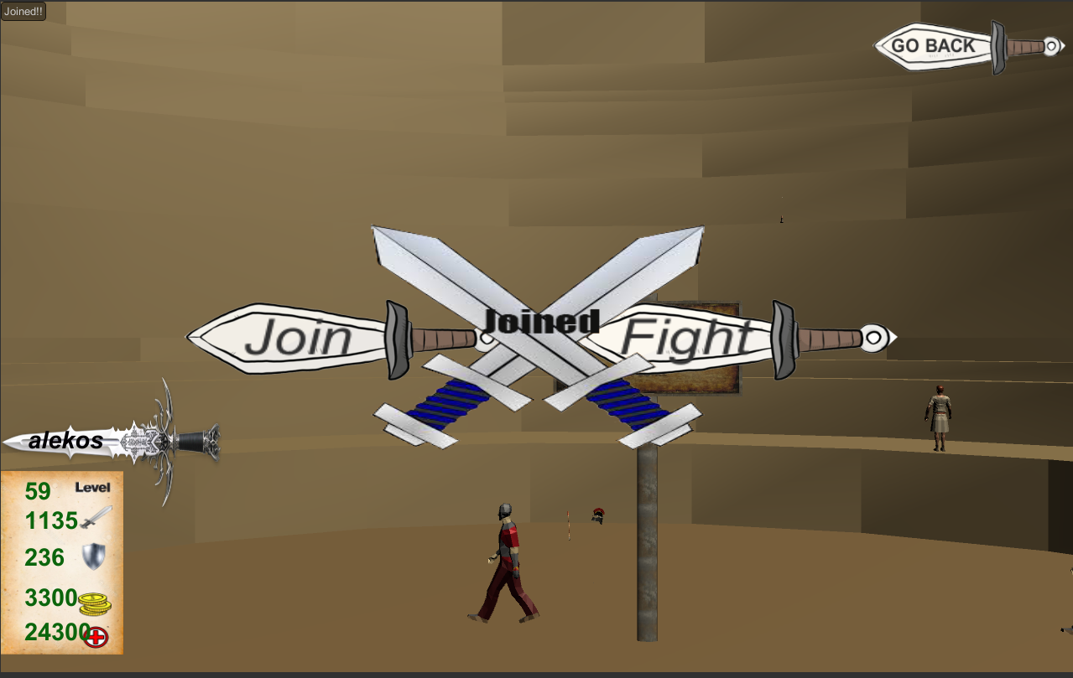

Figure :Join A Fight

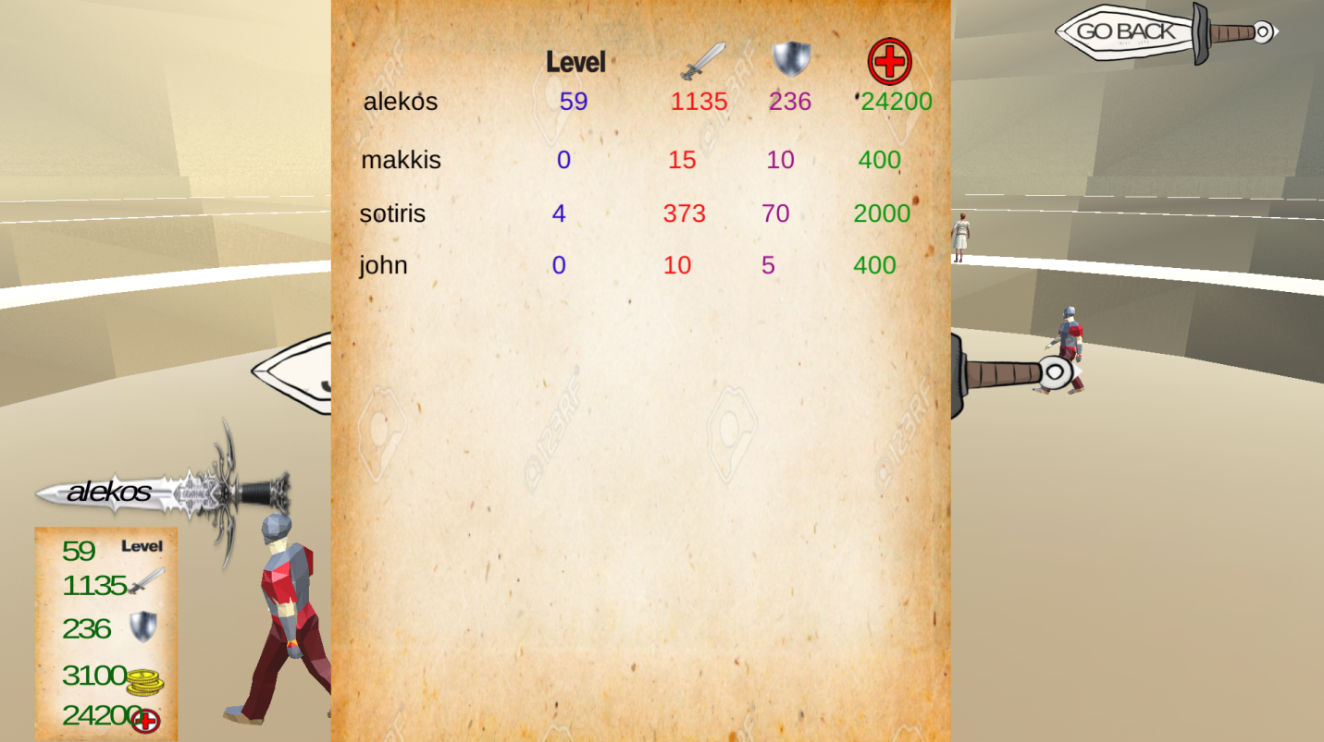

Figure :List With Other Users Joined Already

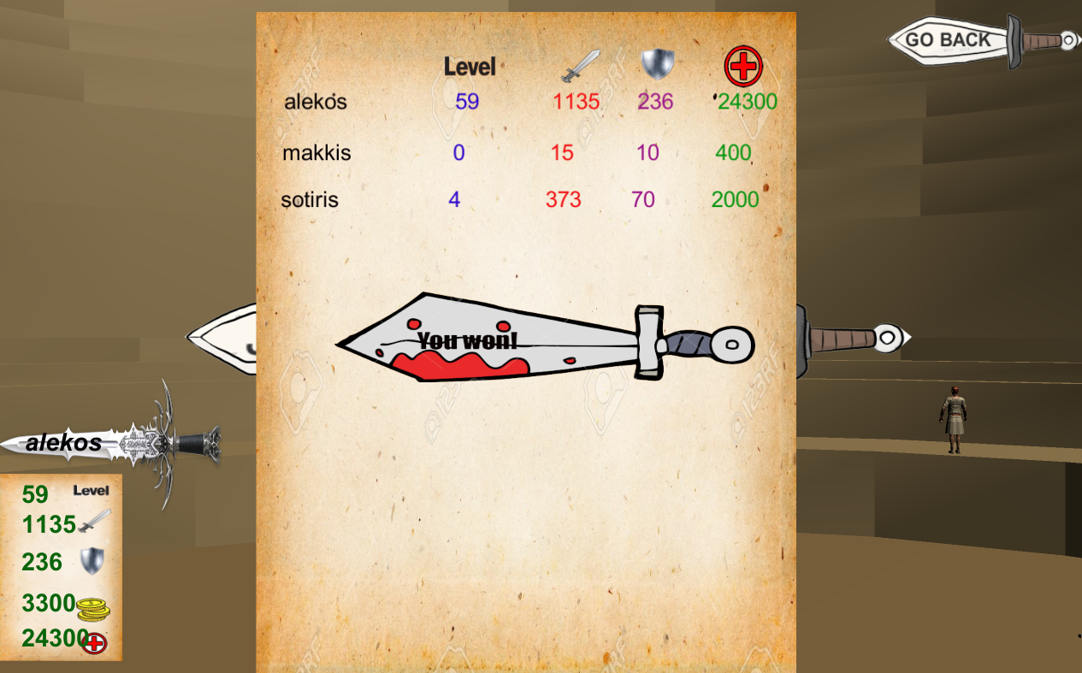

Figure :Text Shown If User Wins The Battle

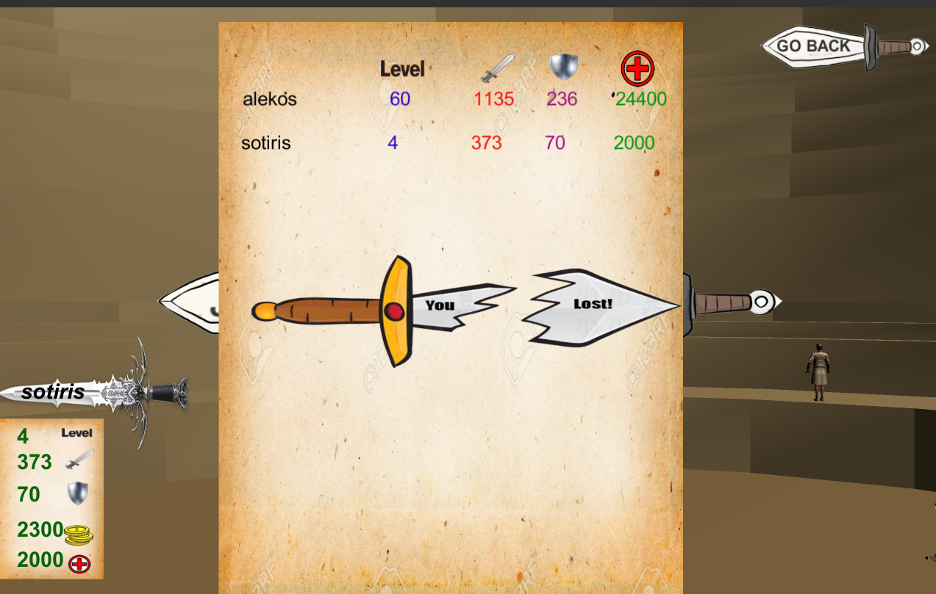

Figure :Text Shown If User Loses The Battle